Analysis of the Aamber Pegasus Memory Map Decoder
by: JAR of http://www.f5IMEchip.com/
(c)17 May 2010
c only displays the $0000-$0FFFan
schematic only displays the $C000-$CFFF(ROM3), $D000-$DFFF(ROM2)am from the proper pin of the decoder chii. This area ($E000-$EFFF) is, in fact, usi

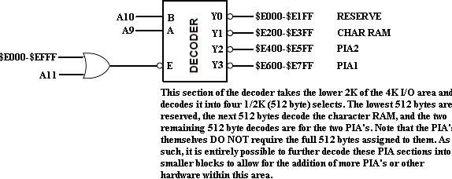

_| X ($0000-$3FTTX$4000-$AF
1 ($4000-$AFFF)

$3FFF>t($4000- $ AFFF)
£>■
I-$3FFF|if related jumper is on])t($4000-$AFFF>t($E800-$EFFF) l-$AFFF>t($E800-$EFFF) |if the jumper is off]

